(Reminder: please always check at SIS for the most updated class schedule.)
Fall 2013-14 (2 Sep – 30 Nov 2013)
Course Code
MGCS 5001(1)
MGCS 5010(1)
MGCS 5021
Course Title
A New History for a New China, 1700-2000:
Advanced
Quantitative Methods in Social Science
Reform and Social Conflicts in Contemporary China
Date & Time
Wed
18:00-20:50
Thu
18:00-20:50
Fri
18:00-20:50
Wed & Fri
13:30-14:50
Wed & Fri
15:00-16:20
Venue
Rm 1003,
LSK Bldg
Rm 4505,
Lift 25-26
UC102, 1/F,
University Center
UC104, 1/F,
University Center
Rm 5507,
Lift 25-26
Instructor
Prof. James Lee
Prof. Albert Park
Prof. Yongshun Cai
Quota
50
50
40
18
18
Credit(s)
3
3
3
3
3
Area of Concentration
Economic and Social History
Quantitative Social Analysis
Contemporary China
Language
Language
LANG 5070(1)(2) Advanced Critical Writing for Academic PurposesDr. Keith Tong
(Section T01)
LANG 5070(1)(2) Advanced Critical Writing for Academic PurposesDr. Susanna Ho
(Section T02)
(Fall Term Examination Period: 9 – 20 Dec 2013)
Remark(1): MGCS 5001, MGCS 5010 and LANG5070 are compulsory core courses. MSc (GCS) students must take these courses.
(2): Section T01 & T02 are identical. Students only need to enroll in either one section.
Spring 2013-14 (4 Feb – 29 May 2014)
Course Code
MGCS 5002
MGCS 5003
MGCS 5020(3)
MGCS 5022
Course Title
The Economy and Society in Imperial China
Comparative Study of State Formation
Chinese Social Stratification in Comparative Perspective
Political Economy of China
Date & Time
Fri
0900-1200
Sat
1800-2100
Thu
1300-1600
Fri
1400-1700
Venue
T.B.A.
T.B.A.
T.B.A.
T.B.A.
Instructor
Prof. Bozhong Li
Prof. Wenkai He
Prof. Xiaogang Wu
Prof. Yimin Lin
Quota
40
50
40
50
Credit(s)
3
3
3
3
Area of Concentration
Economic and Social History
Economic and Social History
Contemporary China
Contemporary China
(Spring Term Examination Period: 17-29 May 2014)
Remark(3): MGCS 5020 is a compulsory core course. MSc (GCS) students must take this course.
Summer 2013-14 (Tentative)
Course Code
MGCS 5004
MGCS 5011
MGCS 5023
MGCS 5030
Course Title
Economic History of East Asia--From Tributary Trade to
Maritime Customs Networks
Quantitative Studies of China
China’s Innovation System: Domestic and International
Dimensions
Social Theory & World History
Date & Time
T.B.A.
T.B.A.
T.B.A.
T.B.A.
Venue
T.B.A.
T.B.A.
T.B.A.
T.B.A.
Instructor
Prof. Takeshi Hamashita
Prof. Satoru Shimokawa
Prof. Erik Baark
Prof. Joshua Derman
Quota
T.B.A.
T.B.A.
T.B.A.
T.B.A.
Credit(s)
3
3
3
3
Area of Concentration
Economic and Social History
Quantitative Social Analysis
Contemporary China
Comparative Humanities
(Reminder: please always check at SIS for the most updated class schedule.)
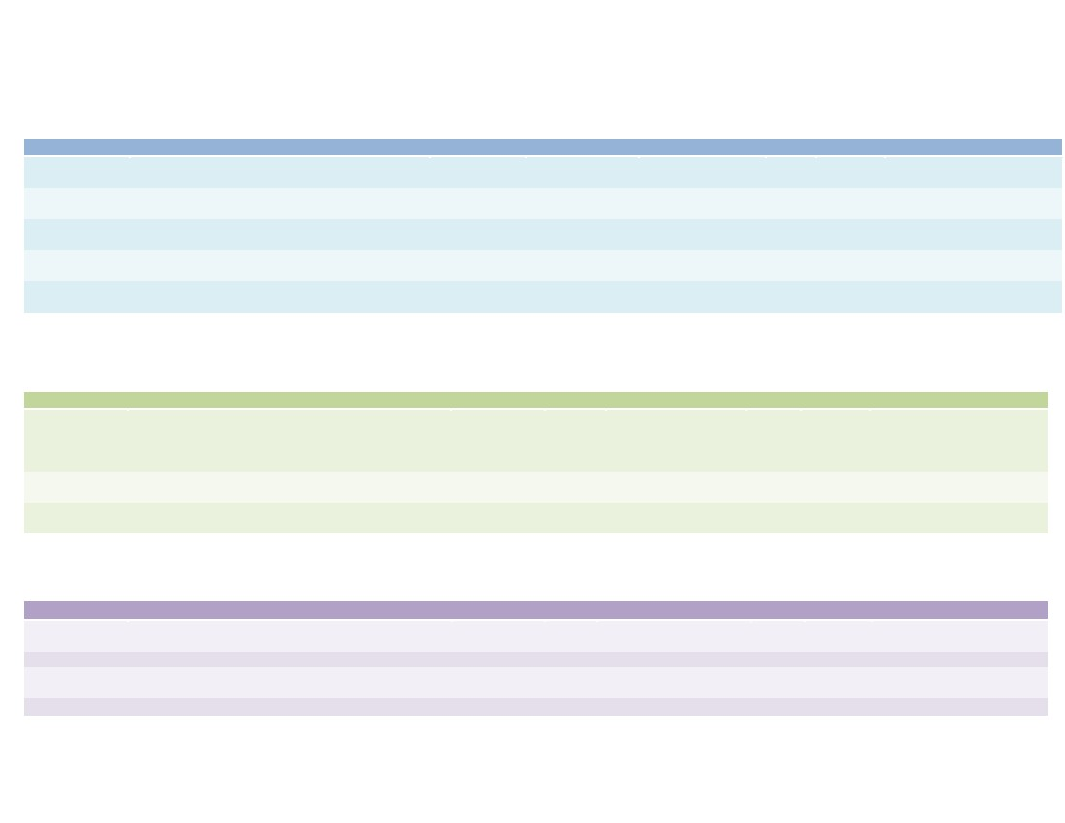 MSc in Global China Studies
Course Offering Schedule 2013-14
Fall 2013-14 (2 Sep – 30 Nov 2013)
Course Code
MGCS 5001(1)
MGCS 5010(1)
MGCS 5021
Course Title
A New History for a New China, 1700-2000:
Advanced
Quantitative Methods in Social Science
Reform and Social Conflicts in Contemporary China
Date & Time
Wed
18:00-20:50
Thu
18:00-20:50
Fri
18:00-20:50
Wed & Fri
13:30-14:50
Wed & Fri
15:00-16:20
Venue
Rm 1003,
LSK Bldg
Rm 4505,
Lift 25-26
UC102, 1/F,
University Center
UC104, 1/F,
University Center
Rm 5507,
Lift 25-26
Instructor
Prof. James Lee
Prof. Albert Park
Prof. Yongshun Cai
Quota
50
50
40
18
18
Credit(s)
3
3
3
3
3
Area of Concentration
Economic and Social History
Quantitative Social Analysis
Contemporary China
Language
Language
LANG 5070(1)(2) Advanced Critical Writing for Academic PurposesDr. Keith Tong
(Section T01)
LANG 5070(1)(2) Advanced Critical Writing for Academic PurposesDr. Susanna Ho
(Section T02)
(Fall Term Examination Period: 9 – 20 Dec 2013)
Remark(1): MGCS 5001, MGCS 5010 and LANG5070 are compulsory core courses. MSc (GCS) students must take these courses.
(2): Section T01 & T02 are identical. Students only need to enroll in either one section.
Spring 2013-14 (4 Feb – 29 May 2014)
Course Code
MGCS 5002
MGCS 5003
MGCS 5020(3)
MGCS 5022
Course Title
The Economy and Society in Imperial China
Comparative Study of State Formation
Chinese Social Stratification in Comparative Perspective
Political Economy of China
Date & Time
Fri
0900-1200
Sat
1800-2100
Thu
1300-1600
Fri
1400-1700
Venue
T.B.A.
T.B.A.
T.B.A.
T.B.A.
Instructor
Prof. Bozhong Li
Prof. Wenkai He
Prof. Xiaogang Wu
Prof. Yimin Lin
Quota
40
50
40
50
Credit(s)
3
3
3
3
Area of Concentration
Economic and Social History
Economic and Social History
Contemporary China
Contemporary China
(Spring Term Examination Period: 17-29 May 2014)
Remark(3): MGCS 5020 is a compulsory core course. MSc (GCS) students must take this course.
Summer 2013-14 (Tentative)
Course Code
MGCS 5004
MGCS 5011
MGCS 5023
MGCS 5030
Course Title
Economic History of East Asia--From Tributary Trade to
Maritime Customs Networks
Quantitative Studies of China
China’s Innovation System: Domestic and International
Dimensions
Social Theory & World History
Date & Time
T.B.A.
T.B.A.
T.B.A.
T.B.A.
Venue
T.B.A.
T.B.A.
T.B.A.
T.B.A.
Instructor
Prof. Takeshi Hamashita
Prof. Satoru Shimokawa
Prof. Erik Baark
Prof. Joshua Derman
Quota
T.B.A.
T.B.A.
T.B.A.
T.B.A.
Credit(s)
3
3
3
3
Area of Concentration
Economic and Social History
Quantitative Social Analysis
Contemporary China
Comparative Humanities
Note: In exceptional circumstances, students may substitute up to six credits (two courses) from other postgraduate courses offered by the School of Humanities and Social Science to fulfill
the MSc (GCS) program requirements with prior approval of the Academic Director. The approved substituting courses should be China-related.
附件3：

